TGMS DevOps Strategy

Contents

1. Branching

1.1 Branching strategy

1.2 Branch sync

1.3 Branch Clean-up

1.4 Branch Policies

1.5 Pull Request

2. Pipeline

2.1 Build Pipeline

2.2 Release Pipeline

2.2.1 Stages

2.2.2 Deployment conditions

2.3 Hotfix pipeline

2.4 Library (Variables)

2.5 Task Groups

3. Service Connection

4. Agents

1. Branching
1.1 Branching Strategy:
- Main Branch:
- Root branch represents the production-ready code.
- Code is merged here only after rigorous testing and approval.
- Protected with branch policies such as mandatory pull requests (PRs), code reviews.
- Release Branch (Staging):
- Immediate child of the Main branch.
- Used for staging deployments and integration testing before production release.
- Code is merged here from the Dev branch after each sprint.
- Protected with branch policies such as mandatory pull requests (PRs), code reviews.
- Dev Branch:
- Immediate child of the Release branch.
- Central branch for integration of all Feature branches within a sprint.
- Code from completed features is merged here after successful testing in the feature branch.
- Protected with branch policies such as mandatory pull requests (PRs), code reviews.
- Feature Branch:
- Child of the Dev branch.
- Created per sprint, user story, or epic.
- Developers work on User Branches and merge their completed work to the Feature branch via pull requests.
- Naming convention: Feature/<sprint>.
- User Branch:
- Immediate child of the Feature branch.
- Created by individual developers for specific tasks.
- Work is done here and tested locally before creating a pull request to the Feature branch.
- Naming convention: User/<developer_short_name>.
- Hotfix Branch:
- Immediate child of the Main branch.
- Created for urgent fixes in production.
- Naming convention: Hotfix/<issue_id>.

- Backup Branch:
- Create a dedicated backup branch for the Main branch to preserve the production state before deploying code after every sprint.
- Naming Convention: Backup/<date_or_sprint_id> (e.g., Backup/2025-01-20 or Backup/sprint12).
Purpose: This branch acts as a rollback option in case of issues during deployment or production failures.

1.2 Branch Refresh Strategy:
- Refreshing Lower Branches:
- Periodically merge the Main branch into the Release branch to ensure that any changes from production are available in staging.
- Merge the Release branch into the Dev branch to propagate staging updates.
- For features that span multiple sprints, rebase the Feature branch on the latest Dev branch code.
- Hotfix Sync:
- When a Hotfix branch is completed:
- Merge it into Main to deploy to production.
- Backport the changes to Release and Dev branches to avoid regressions in future releases.
1.3 Branch Cleanup:
- Delete completed feature, User, and hotfix branches after merging.
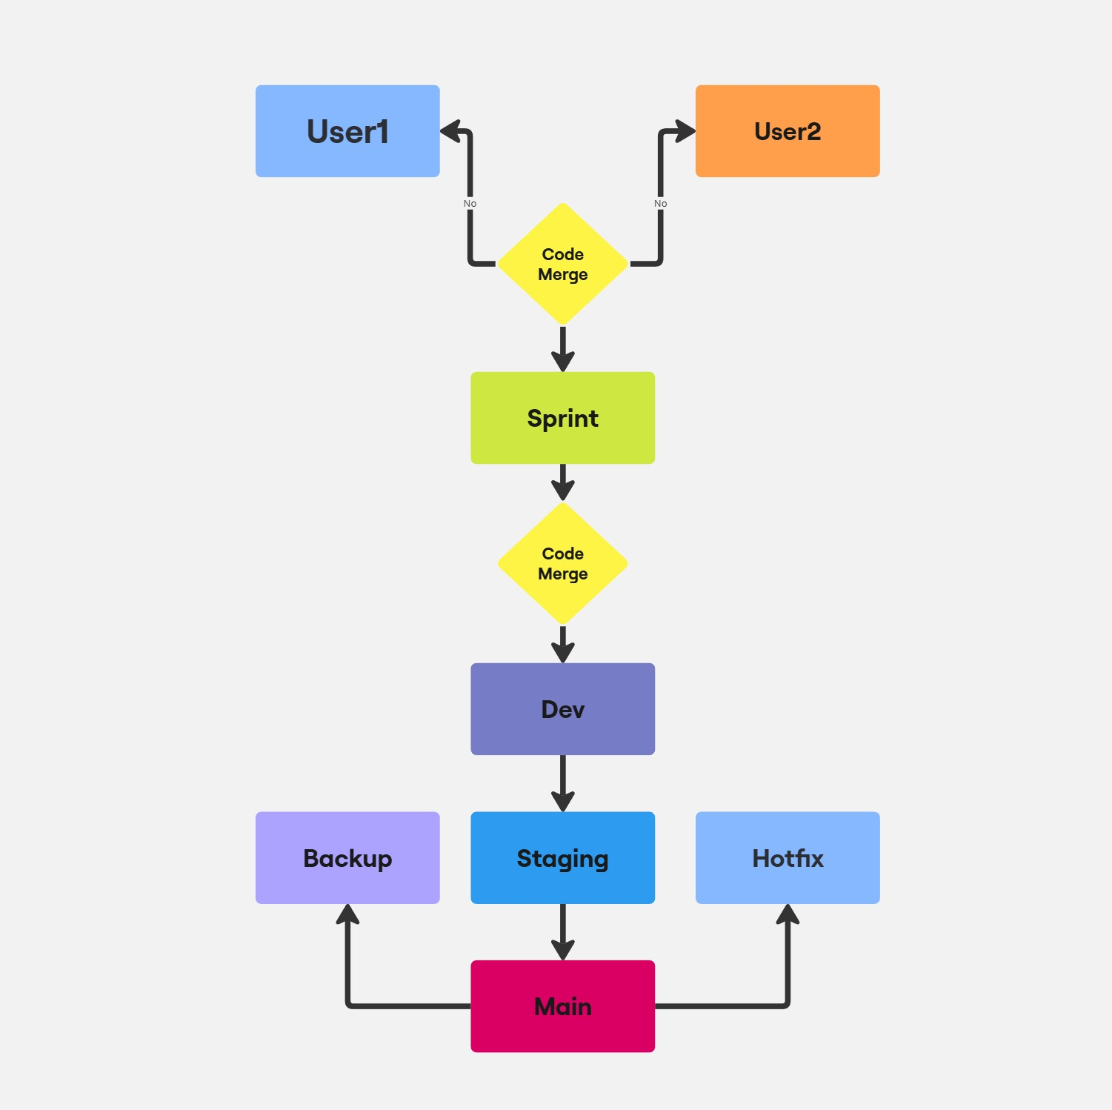

  - Branch Policies

Branch policies help teams protect their important branches of development. Policies enforce team's code quality and security activities.

  - Pull Request

A pull request (PR) in Azure DevOps is a way to review and merge code changes in a Git repository. PRs are a collaborative process that allows teams to review code and provide feedback before merging it into the main branch.

- Pipeline Strategy:
2.1 Continuous Build Pipeline:
- Purpose: Validate code changes with automated builds.
- Trigger: When a pull request is created for merging into Dev, Release, or Main branches.
- Steps:
- Pull the latest code from the respective branch.
- Install dependencies and configure the environment.
- Run Build.
- Publish build artifacts for downstream pipelines.
Naming Convention: CI/<branch_name>
Example: CI/Dev

  - Release Pipeline:
- Purpose: Automates deployment of code to Dev, Staging and Production environments.
- Trigger: Manual triggered on merges to the Dev, Release or Main branches. Can be Automatic triggered for specific deployments.

- Steps:
- Fetch build artifacts from the CI pipeline.
- Deploy to the staging environment (for Dev/Release branch).
- Upon approval, deploy to the production environment (for Main branch).
- Perform smoke tests to validate production deployment.
Naming Convention: Release/<environment_name>
Example: Dev/Dev, Release/Staging or Main/Production
2.2.1 Stages
A stage is a logical boundary in the pipeline. It can be used to mark separation of concerns (for example, Build, QA, and production). Each stage contains one or more jobs. When you define multiple stages in a pipeline, by default, they run one after the other.
Stage contains below.
- Job Details
- Task details

2.2.2 Deployment conditions

Deployment conditions refers to a set of rules or criteria that determine when a deployment should occur within a release pipeline.
  - Hotfix Pipeline [Optional]
- Purpose: Quickly deploy critical fixes to production.
- Trigger: Manual triggered on merges to the Hotfix branch.
- Steps:
- Build the hotfix code.
- Deploy directly to Hotfix/Staging and Test.
- Deploy directly to production if Test pass.
- Merge the changes back to Main, Release, and Dev branches to ensure consistency.
Naming Convention: Hotfix/<issue_id>
Example: Hotfix/12345
  - Library (Variables)
Variable is a name-value pair that allows you to store and dynamically access data within your pipeline, providing reusable values that can be used in various parts of your build and deployment process across different stages of your pipeline.

2.5 Task Groups
Task group encapsulates a sequence of tasks that are already defined in a pipeline into a single reusable task.

